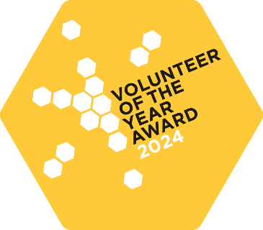Arts and Culture East Devon (ACED) Volunteer of the Year Award

We are delighted to introduce the award for ACED Volunteer of the Year.
This award has been created to celebrate the outstanding contributions and commitment of our dedicated volunteers in the East Devon creative sector.
The award recognises an outstanding contribution to culture for a volunteer who has gone above and beyond their role.
Eligibility for ACED Volunteer of the Year Award is open to residents of East Devon who perform a volunteer role benefiting the arts and culture sector in East Devon.

Contact information for proposer of the volunteer:
Name:
Organisation (if applicable):
Email:
Nominee name:
Nominee organisation:
Please describe how the nominee has contributed to arts and culture in East Devon and why they are deserving of the ACED Volunteer of the Year Award. What have they accomplished? How have they made a difference? How have they gone above and beyond the role? (max 300 words):

Please list three words that describe the nominee:
1.
2.
3.
If possible, please attach a photo of the nominee relating to their volunteering activity (this is not required for nomination).

