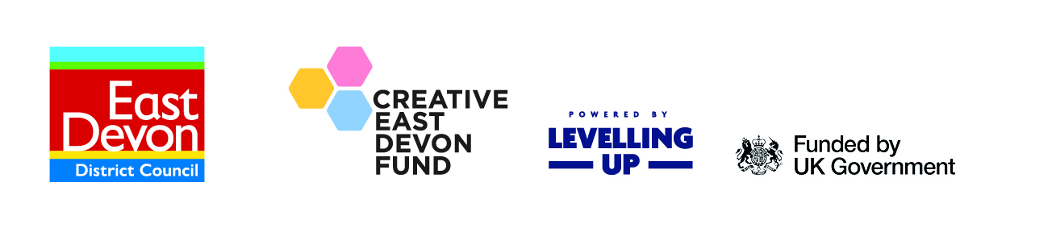

Creative East Devon Grant - Application Form: Round 2

All sections are to be submitted via our online form. The purpose of this Word Document is so you can view the required questions in advance of completing the online form.

Section A – Applicant details
- Organisation name:
- Contact name:
- Role/Job title:
- Telephone:
- Email:
- Website:
- Organisation address:
- Organisation status:
Registered charity (state charity number), ​Organisation with charitable aims, ​Company limited by guarantee (state company number), Community Interest Company (state CIC number), Club or association)

- Link to ACED Directory profile:

Section B – Project details
Please aim to keep answers to the below questions under 150 words.
- Project title:
- Please describe the project or activities for which you require funding:
- Project Location:
- Project start date:
Anticipated completion date:
NB: Round 2 of this scheme will fund activity running until March 2025.
- How do you intend to deliver your project between your proposed start date and anticipated completion date? Please set out your key project milestones and timeline
- What are you hoping to achieve and how? Please describe the expected wider outcomes/impacts that your project will achieve, both short term and long term.
- How does your project directly contribute to the East Devon Cultural Strategy? Please specify which Theme in the Strategy your project aligns to.
- Is your project linked to other projects and/or strategies? For example the Council’s Climate Change Strategy or Tourism Strategy. If so, please give details.
- Do you have appropriate liability insurance for this activity? Yes/No/Not Applicable
- We want children and young people across the district to feel they have ample opportunities to take part in cultural and creative activities. Which age groups are you and your project targeting? Tick all that apply.
1-4 (pre-school age) ​☐​
5-10 (primary school age) ​☐​
11-15 (secondary school age) ​☐​
16-24 (college/university age) ​☐​
25-35 (young adult age) ​☐​
36-54 (adult age) ​☐​
55-65 (mature age) ​☐​
65+ (retired age) ​☐​
- How many people will engage/benefit from your project? E.g. if you are delivering workshops how many will attend, or if you are running an event how many audience numbers do you anticipate?

- Please describe how your project / activities promote equal opportunities and accessibility for all and how you plan to monitor diversity, equality and inclusion in your work.
- What evidence do you have of community support and/or a demand or need for your project?
- Have you obtained all permissions you require to carry out the project? Yes/No

Section C – Financial details
Please note that the ‘Total project cost’ amount must equal the ‘Grant applied for’ plus the ‘Match funding contribution’ amounts.
- Total project cost (£):
- Grant applied for (£):
- Please list what you will be spending your grant funding on:

Item | Value  (£)
Total Costs

- Match funding contribution (£):
Your 'Match funding contribution' must be a minimum of 10% of the 'Total project cost' to proceed with your application

- Please list all sources of financial support you are seeking from either in cash or in-kind.

Name of organisation | In Kind | Cash | Details and estimated or confirmed decision date*
Total Income

- How will you ensure good value for money?
You may want to outline what your procurement process is, how many quotes have you had? Are you using existing materials or second-hand equipment?
- Have you applied for other EDDC funding for this project, or previously received funding from a community fund in the last 3 years?
If yes, please specify:

Date | Funder | Project | Amount

- Organisation Bank Details

Bank/Building society name
Account Name
Account number
Sort code

- Please upload or email the below to aced@eastdevon.gov.uk
​☐​ Accounts for last financial year
​☐​ Business Bank Statement

Section D – Outcomes and Outputs
This scheme is funded by the UK Government through the UK Shared Prosperity Fund which has specific outputs and outcomes. This section only requires completion if your requested grant amount is above £1500. If your project is below this threshold, please progress to Section E.
- Please select from the list below at least one output or outcome that will be met by your project and the number that will be achieved:

Output or Outcome | ✓ | Number/value
Local events or activities supported
Volunteering opportunities supported
Improved engagement numbers
Improved perception of events
Improved perception of facilities/amenities
Increased footfall
Jobs created
Community-led arts, cultural, heritage and creative programmes created
Increased visitor numbers

- Please explain how the outputs and outcomes above will be measured:

Section E – Applicant declaration
Please read and sign:
I certify that I have been authorised by the organisation stated in this application to complete this application form. I certify that all information provided is true to the best of my knowledge.
I understand that any materially misleading statements given at any stage during the application process could render the application invalid. I also understand that if the project is not completed, the applicant may be required to return part, or all, of the money paid.
I understand this application is not confidential and may be made available for inspection by the public.
In signing and submitting your application I agree to allow East Devon District Council to retain my personal data on its database and to use this information to help assess my application and administer any grant they award. In doing so information provided may be disclosed to council officers and elected members. We may publish amounts awarded to successful applications on our website and other promotional materials.
I understand that all grant recipients will need to complete a short evaluation form by March 2025 and a full report will be published in Spring/Summer 2025.
​☐​ I confirm that I have read, understood and agree to the above declaration statement

Thank you.

To apply complete our online form.

Please send any accompanying documents and any relevant supporting information to aced@eastdevon.gov.uk.
If you have any queries about any aspect of the application form, the Creative East Devon Fund, or if you need help and support to develop your project – please don’t hesitate to contact us.

